The application is a Microsoft ASP.Net CORE 2.0 app.

For most of the cases, Microsoft standard coding practices and framework are used. This takes care of performance, scalability, security aspects of the app.

**Structure**:

ContactManager – This is the complete app with UI, middleware and database.

ContactManagerAPI – This provides ReST API for Contact Manager. This uses in-memory database and can be tested using HTTP client – I used Postman.

**Screenshots**:

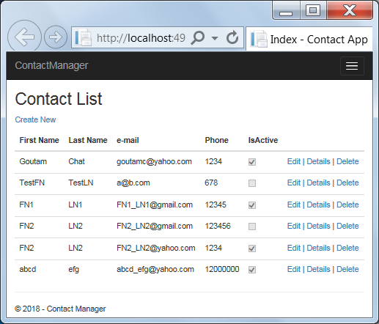

Contact List

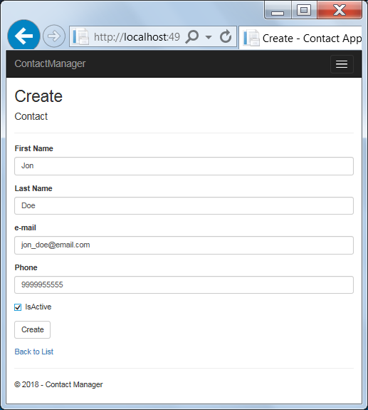

**Contact Creation**

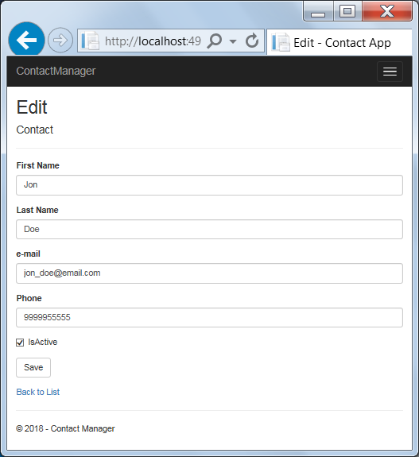

**Contact Update**

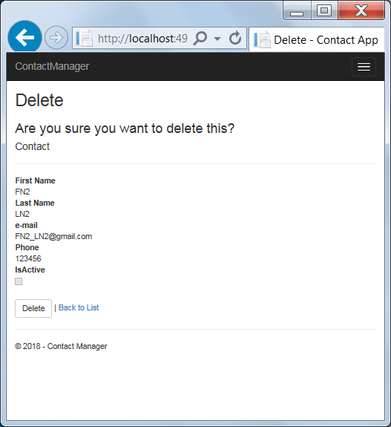

**Contact Removal**

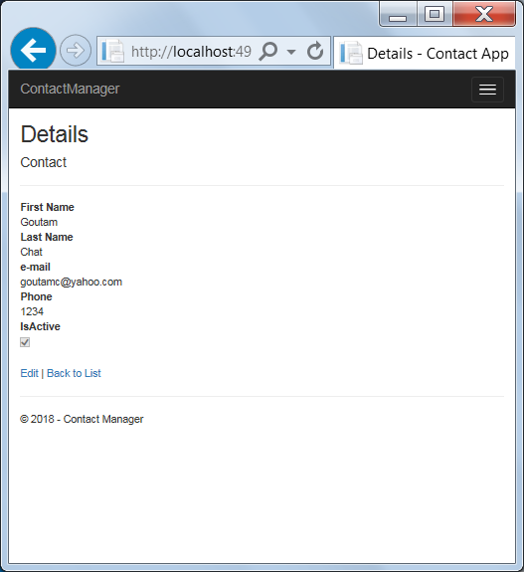

**Viewing Contact**

ReST API service testing:

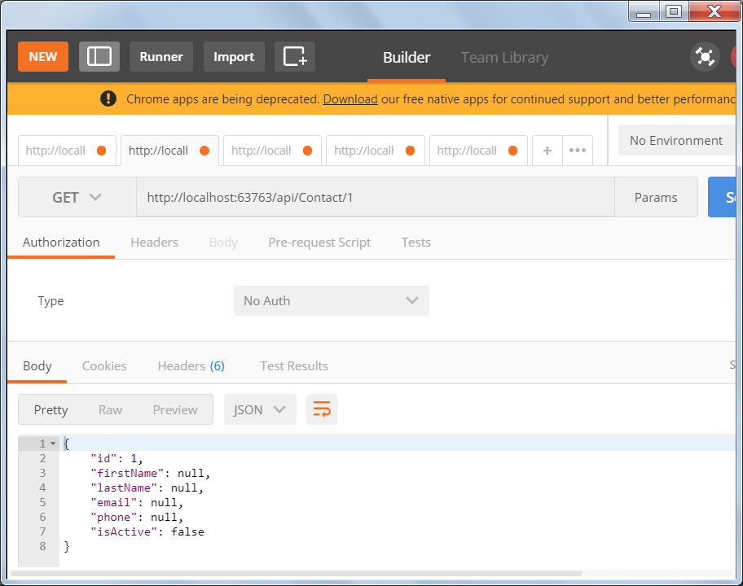

**Getting one Contact information**

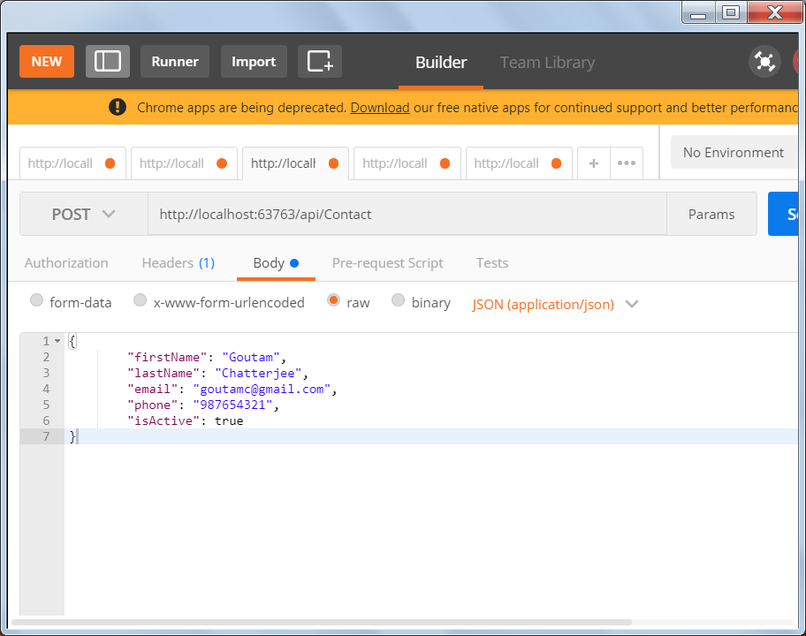

**Creating a new Contact**

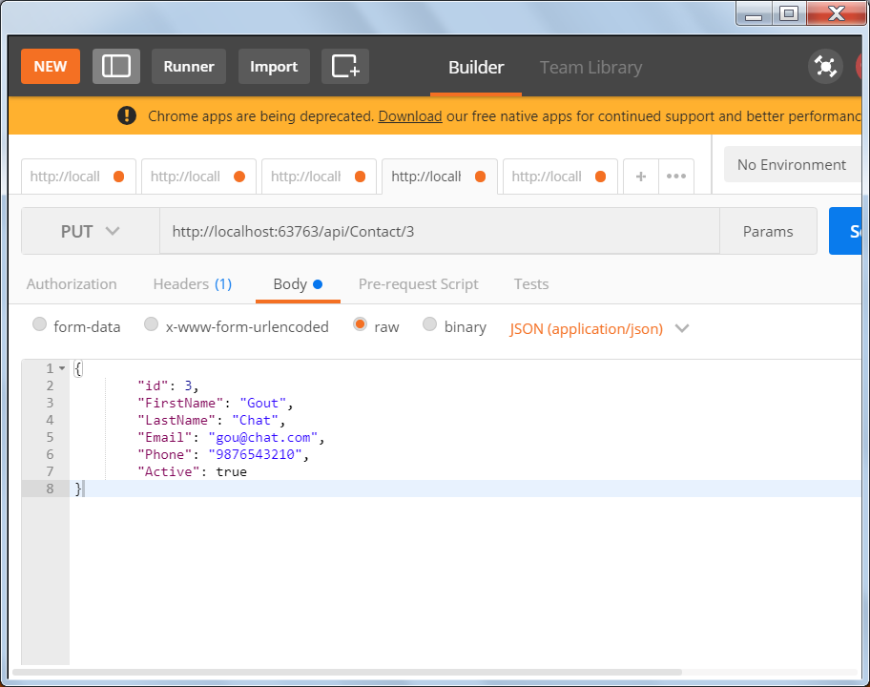

**Updating Existing Contact**

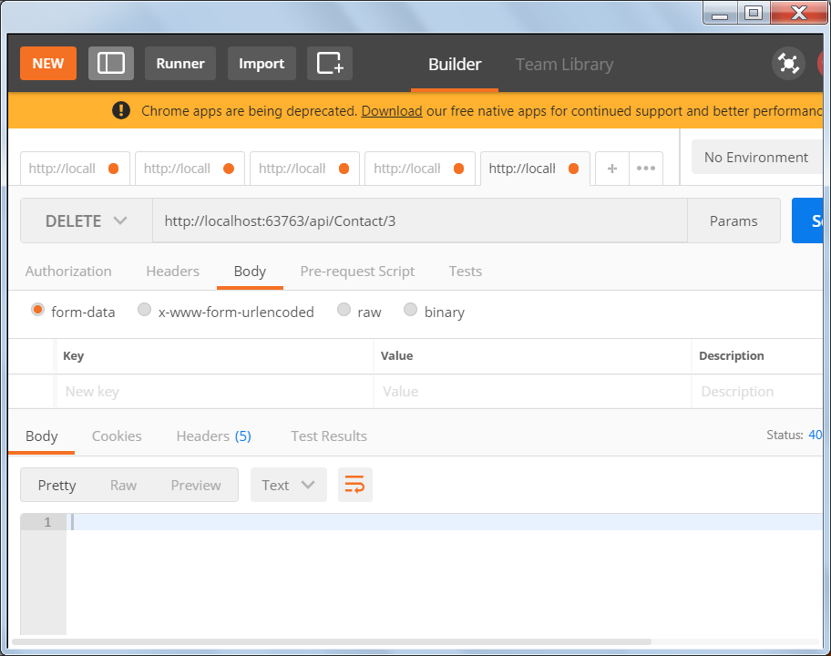

**Deleting a Contact**

**Considerations:**

* **Security** – Microsoft Windows authentication is enabled. Database-backed user authentication can be implemented. Role-based Authorization is not implemented.
* **Hosting and deployment** – The app can be hosted on in-premise IIS or Azure Cloud – I tested it by hosting on IIS Express. All necessary files are there in Published folder. For Production environment, appropriate changes should be made in configuration files.
* **Platform** – The app is developed using Microsoft .net CORE. So, it will run on all platforms (Windows, Mac) as long as a shared system-wide version of .NET Core is there on the target system.
* **Device** – Because of Responsive web design, the app can be used seamlessly on all devices (mobile etc).
* **Unit testing** – is performed by manually testing the scenarios mentioned in problem statement. Microsoft Unit Testing framework can be used for more formal and exhaustive testing.
* **Validation, Business Logic** - Standard and some obvious validation checks are made. Depending on the requirement, other validation logic can be enforced.
* **Functionality enhancement** –
  + Searching contact based on some criteria
  + In-place edit
  + More attributes to Contact
  + Better look and feel